^{Brief Bio}

Name: Soudavar Farmanfarmaian, Fatema
^{Born: 1940, Tehran, Iran}
^{Nationality: Swiss and Iranian}
Languages: Persian, English, French, German, Russian, Italian
Education: Iran and Switzerland
Presently living in Geneva and London, moving to Portugal in late 2022.

^{Present activities:}
Independent researcher and writer (English, Persian, French.
Trustee of the Soudavar Memorial Foundation, Geneva, Switzerland (soudavar.org)

^{List of Publications:}
^{In Persian:}
1973 - To’se’e-ye eghtesadi va masa’el zistmohiti (A collection of essays by various authorities on environmental issues in relation to economic development, with an introductory essay by the editor, F. Soudavar Farmanfarmaian)

1978 and 2006 - Introductory biography for two editions of a posthumous book of novellas and travelogues, Sabeqiya, by the author’s late husband, Abdolali Farmanfarmaian.

1970s - Articles on environmental and demographic issues, and urban problems for the journal of the Department of Environment in Iran, Shekār va Tabi’at.
2015 - ‘Beh yad-e banu-ye honar parvar va farhang dust irani, Banu Ezzat-Malek Malek’ in Barressiha-ye novin-e tarikhi I/2, Tabriz, 1393 AH

2015- ‘Omr-e por bar: yadi az Ezzat-Malek Malek (Soudavar)” in Iran Nameh 30/3, 2015

2018 – Sabeqieh and the Life and Writings of Abdolali Farmanfarmaian (in Persian) with a biography by Fatema Soudavar Farmanfarmaian, Ibex Publishers, Bethesda Md. This is a more complete and uncensored version.

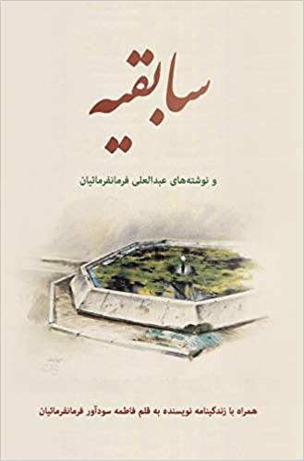

^{In English:}
1996 - ‘James Baillie Fraser in Mashad or The Pilgrimage of a Nineteenth-century Scotsman to the Shrine of the Imam Reza’, in BIPS’Iran 34

2000 – ‘Haft Qalam Arayesh: Cosmetics in the Iranian World’, in Iranian Studies 33:3
(Persian translation in the journal Hasti);

2003 – ‘Haft Qalam Arayesh in Iranian Lands: From Prehistory to the Qajar period’ in International Qajar Studies Association Journal, vol. III

2008 – ‘Persian, Pasionaria and Princess’ (in memoriam of Mariam Firuz)” in Journal of the International Qajar Studies Association, vol. VIII (also available on payvand.com).
A more personal account under the title ‘East Berlin Honeymoon’ can be accessed online.

2009 – ‘Georgia and Iran: Three Millennia of Cultural Relations: An Overview’ in Journal of Persianate Studies 2 (Brill, Leiden).

2010 – ‘The Twin Gardens of Rosewater Valley – Memories’ in Journal of the International Qajar Studies Association vol. IX (Persian translation in Bokhara journal)

2011 - “An Iranian Perspective of J. B. Fraser’s Trip to Khorasan in the 1820s” in Journal of the International Society for Iranian Studies 44:2

2012 - ‘Politics and Patronage: The Evolution of the Sara-ye Amir’ in The Bazzar in the Islamic City, ed. Mohammad Gharipour, published by American University Press, Cario 2012

2012 -‘How the Russians hosted an entrepreneur who gave them a belly-ache: New revelations on Hajj Kazem Malek al-Tojjar and the Russian Connection” in Iranian-Russian Encounters: Empires and Revolutions Since 1800, `ed. Dr. Stephanie Cronin, Routledge, Abingdon.

2013 – ‘Bankers by Appointment to the Qajars’ in Journal of International Qajar Studies Association Vol. XII-XIII
2013 – ‘Opposition to foreign concessions and the anti-tobacco fatwa of 1891’ in the Journal of the Iran Society,

2014 – ‘Iran’s imperilled environment’, co-authored with Dr. Bijan Rouhani.in payvand.com, May 2014

2014 – ‘Revisiting and revising the tobacco concession with Haj Kazem Malek al-Tojjar” in Iranian Studies 47:4.

2016- Foreword to The Spanish Monarchy and Safavid Persia in the Early Modern Period: Politics, War and Religion, Ed. Enrique Garcia Hernan, Jose Cutillas, Rudi Matthee, Valencia 2016

2017 – ‘The Life and Times of Ezzat Malek Soudavar’ in Massoumeh Farhad, Simon Rettig et al. , A Collector’s Passion, Freer Gallery Catalogue, Smithsonian, Washington D.C.

2018 - Review of Matthee, Floor, Clawson, The Monetary History of Iran, in Iranian Studies 52:5, 790–95, July 2018.

2020 – ‘Of banknotes and bijaks’ – in ECIS 8 Proceedings Vol. 2, Moscow 2020.

And various interviews and talks on cultural heritage

